**TABLEAU PROJECT**

**INTRODUCTION :-**

We have a data of orders that customer had bought, thorough this data we can have a overview of the sales, profit in respect to country, region, state. By this we can have the pictorial representation of states or region where we have highest sales through this we can analyse demand and supply of products in particular region or state which will bring conclusion to understand demand and supply accordingly.

**METHODOLOGY :-**

In sheet 1 we have numbers related to discount, sales, quantity and profit where we can analyse numbers in particular region for product category using filters. Then we have quarter wise sales and year wise profit and at last we have sub category wise sales with all the filters available for category, region, segment, sub category so that we have data sorted accordingly. Then there is dashboard in which we have it all together to better understand all the scenarios in one view only.

**REQUIREMENT ANALYSIS :-**

WE WERE REQUIRED TO CHECK IN WHICH YEAR WE HAVE HIGHEST SALES AND FOR WHICH PRODUCT AND ALSO WHICH PRODUCT IS GIVING US MORE PROFIT AND IN WHICH REGION WE NEED TO ANALYSE ALL THE DATA AND GET REQUIRED OUTPUT

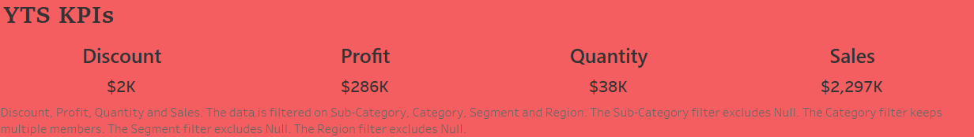

In this we can see all over discount provided to customer is $2K , profit is $286K, quantity is $38K, sales is $2,297K including all the region and category of product. By using filter we can check this data region / category wise.

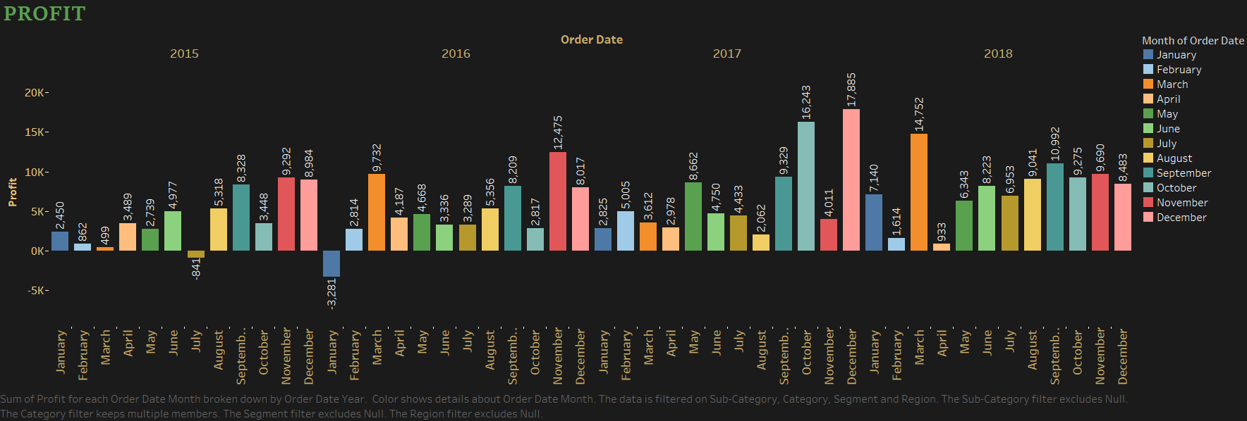

According to this we have highest profit in year 2017 of $17885.31 but we have also faced loss in the year 2015, 2016.

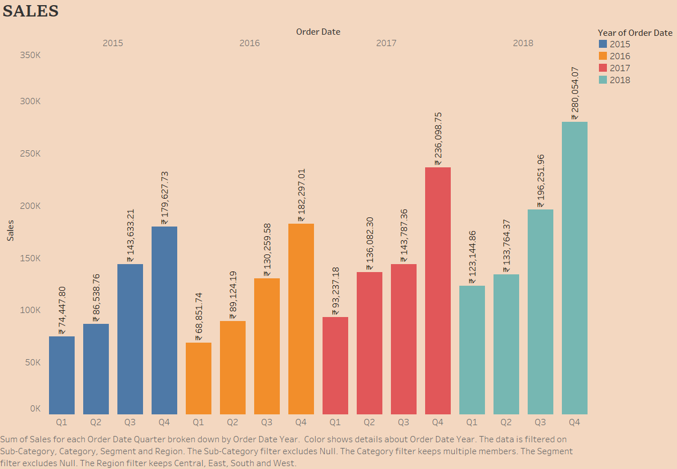

Here we can see that we have highest sales in the year 2018 in quarter 4 of $280,054.07. According to this visualization we can see that our sales are increasing in every quarter from 2015 which means our product have the highest demand in the quarter 3 and 4.

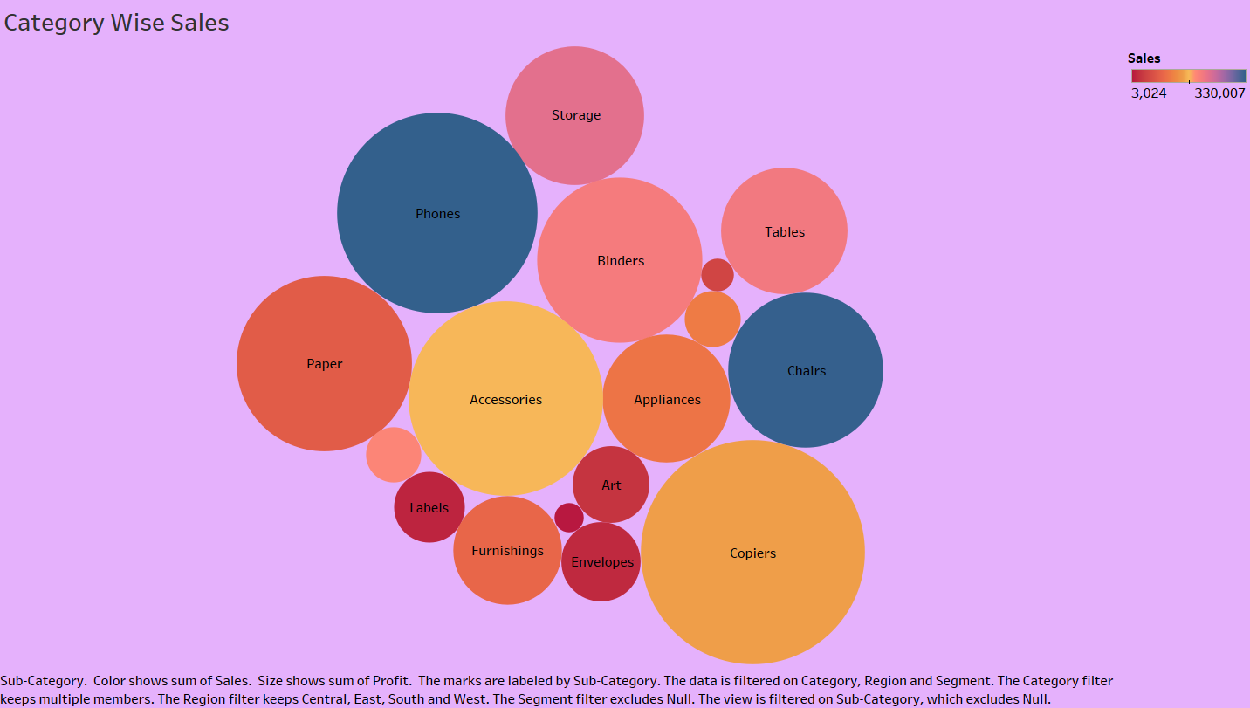

Through this we can analyse which product is having highest sales and profit.

As we can see area covered by copiers is more than any other category which means copiers is having highest sales and profit.

**CONCLUSION :-**

By this we can conclude that our sales are increasing year by year but profits do have fluctuating pattern we have highest profit in the year 2017 and in 2018 we are not able to huge positive changes in profit numbers, which means that we need to do cost cutting in production, import, export etc as our sales are increasing but profits are not that means our cost of production is more and because of this we are not able to save more on profits. Also we have highest sale for phones and highest profit for copiers so we can focus more on these 2 products.